Suppose that you are a pottery artist and want to create a special color to paint your work of art. Using the primary colors of red, green, and blue (or RGB) and the skills you've acquired in this class, combine the three primary colors to create new color schemes for painting your art work.
- Describe how you would mix your color mathematically.
- What subspace would you operate in?
- List your base vectors and describe them.
- If you want to vary the intensity of certain colors, how would you do it?
- What does vector addition do to your color scheme?
- What does positive scalar multiplication do to your color scheme?
- Give a vector representation of your favorite color. Explain the steps you undertake to make this color and name it.

1.
So to make this simple I would just have a vector of [x1 R, x2 G, x3 B]
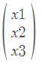
Therefore I could do calculations on the RGB color to other RGB vectors if needed.
2. My subspace would be all color which have certain colors look, such as:
(Orange set of vectors)
(Green set of vectors)
(Red set of vectors)... etc

3. My base vectors would be :

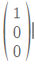 This is my base red vector which states all my greens = 0 and Blue = 0 and Red = 1.
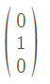This is my base red vector which states all my greens = 1 and Blue = 0 and Red = 0.
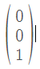This is my base red vector which states all my greens = 0 and Blue = 1 and Red = 0.

4. To increase the intensity of a certain color you could just add the base of the color to your current vector such as:

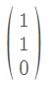+ (000)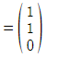

5. Vector addition gives me the ability to add different colors to my vectors. This would allow me to get from one color to another and I can mathematically tell how far certain colors are from one another.

6.positive scalar multiplication gives me the same ability as vector addition but just more exponential growth or decrease.

7. 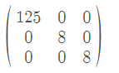I would call this color Marron 5 because it's a shade of maroon and it took me 5mins to create. I just took the red base and added more red and some green and blue.

